**Malik Abdullah Naazar**

**20-Arid-872**

**BSSE_5_A_Evening**

**Computer Networks**

**Lab Manual 2**

**___________________________________________________________**

1. **ipconfig**

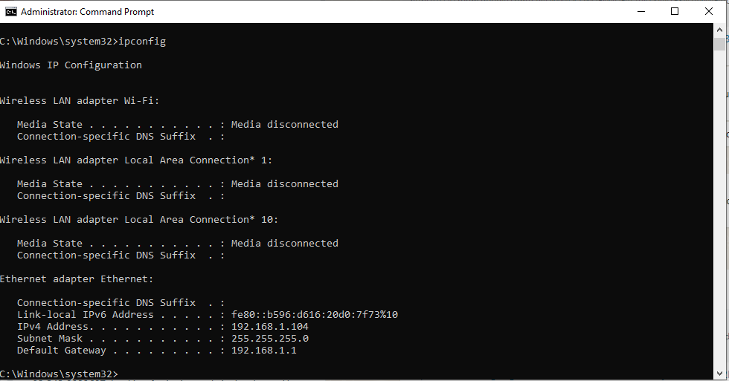

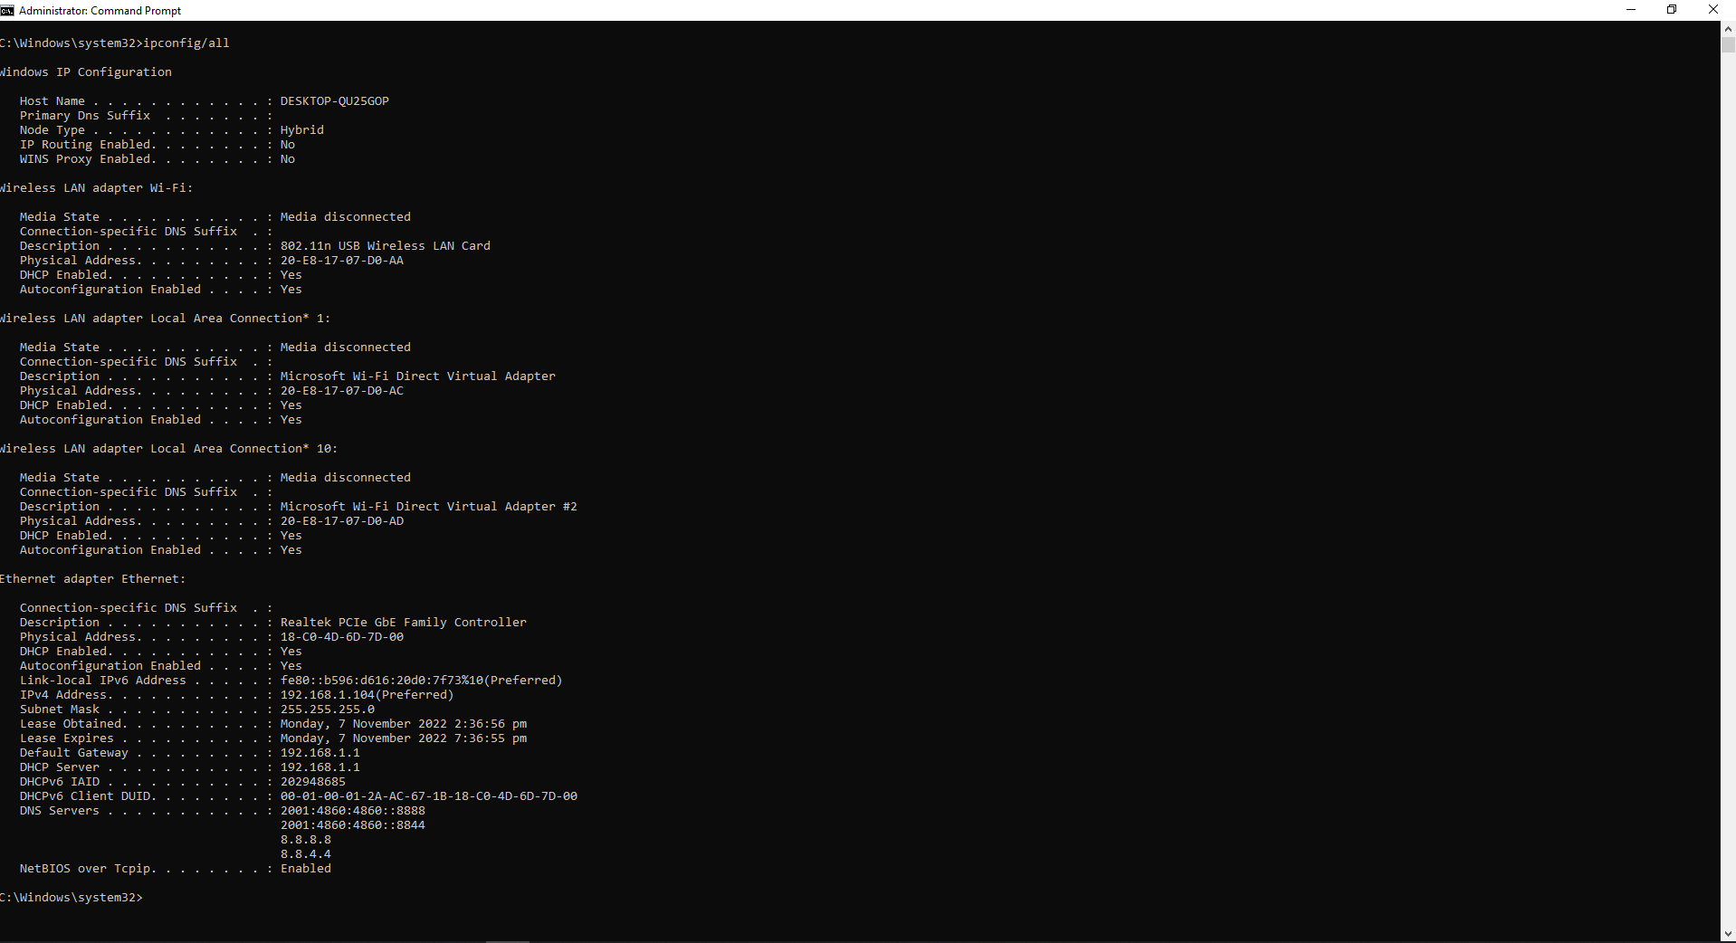

1. ping

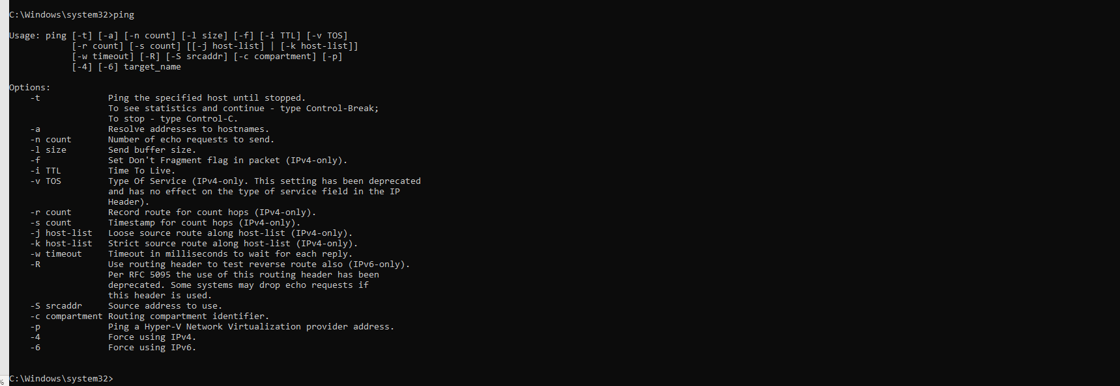

1. ping 192.168.1.104 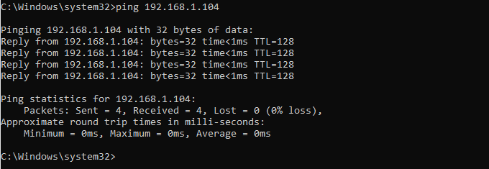
2. ping [www.google.com](http://www.google.com)

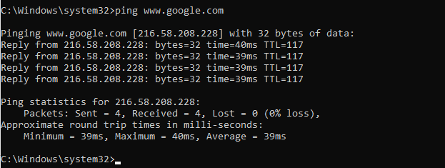

1. **tracert** [**www.uettaxila.edu.pk**](http://www.uettaxila.edu.pk)

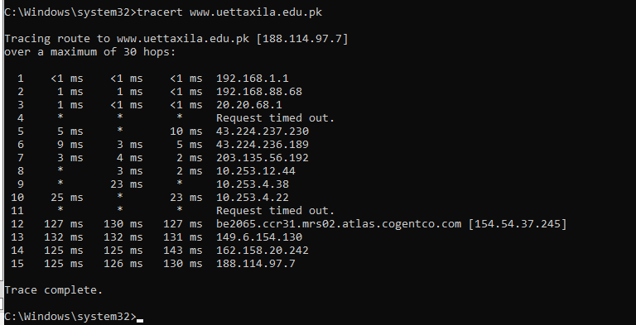

1. arp -a

